42.21: a) 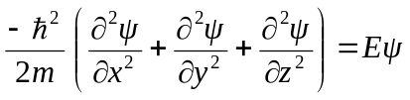
where 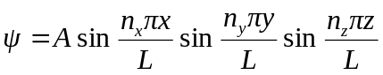
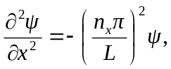 and similarly for 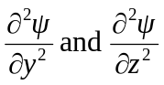.
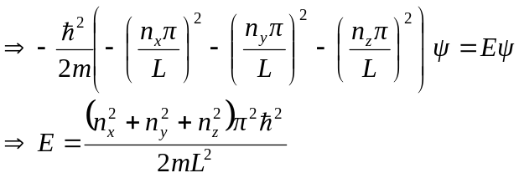
b) Ground state 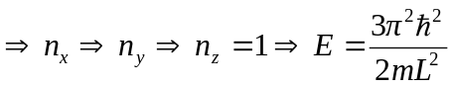,
The only degeneracy is from the two spin states. The first excited state 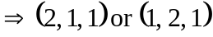
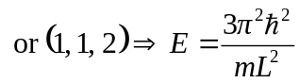 and the degeneracy is 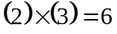.
The second excited state 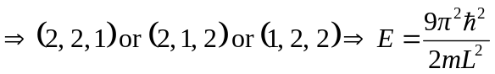 and the degeneracy is .

